Course: INFO 531/ISTA 431: Data Warehousing and Analytics in the Cloud
Module/Week: 5 - Week of September 19, 2022
Topic: Data Warehouse Governance Best Practices; Performance Optimization in Data
Warehouses
Ripa Shah
Enterprise Data Warehouse Governance Best Practices
Data governance is all about bringing discipline into coding, designing and maintenance standard of data warehousing. A certain key areas of data warehouse activities need to be governed in a disciplined manner. This article is focusing on to identify the best practices which can be followed in building and maintaining data warehouse. As time passes data tends to grow in a large volume.
The data originates from the operational databases. The source system provides change timestamps for temporal data. The source systems loaded into staging tables. The staging table accessed via L1 views. This data is mainly used to build L2 and L3 layers. The ETL (Extract Transform and Load) method has been used to shift data from L1 view to L2 and L3 layer. L2 subject areas are shared subject areas and used by applications that needs data. L3 subject areas are dedicated to specific application. Each L3 subject area provides the analytical environment used for business intelligence and reporting purposes. The business view point to base view. The base view reaches to different subject area layers. Users are not permitted to access the tables directly. They have access according to their roles and data needs.

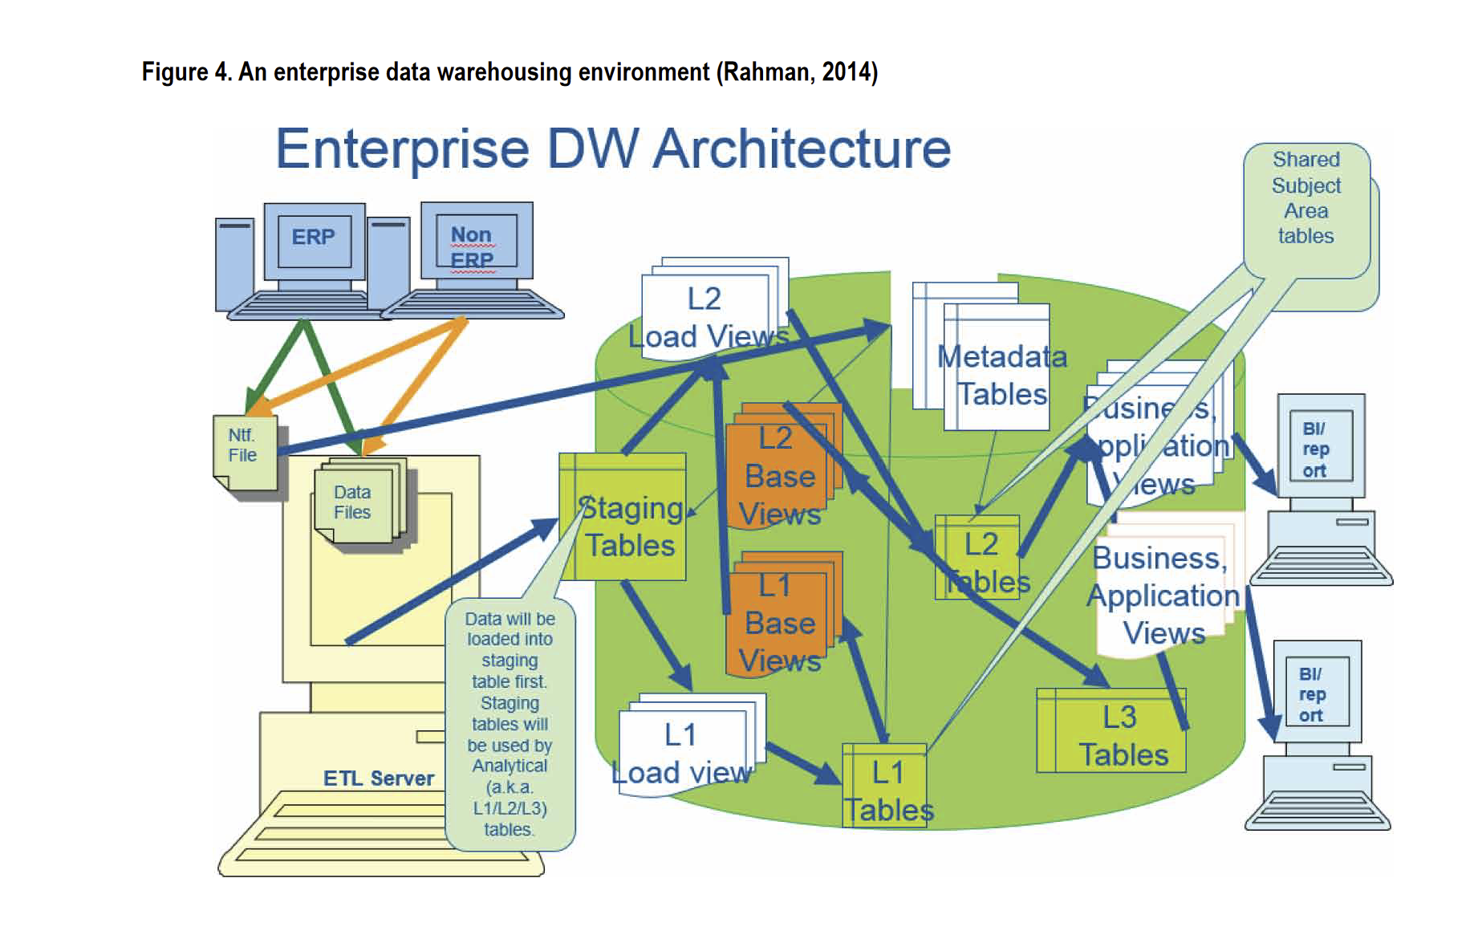

To implement a balanced approach, we need to think by two perspectives: First, we should also think about the load process and performance. On the other hand, we also need to think about the reporting perspective. After loading and processing the data, we also need to view the reports. It must be balanced approach. Thousands of batch processing has been run in the data warehouse to load the staging and analytical databases. Jobs must be visible and viable to support team. For that, we must have to implement the scheduling jobs. Jobs in different subject areas are run in varied frequencies according to service level agreement (SLA). Master scheduling requires where existing demand peaks and valleys; the business requirements for query performance and availability of data and the best estimates for demand or query cycle landing. The optimal window will satisfy business requirements while simultaneously not driving peak demand to the point where additional resources must be purchased. To run batch cycles efficiently and in a timely fashion it is important to ensure that ETL code and jobs perform efficiently. On the other hand, from the reporting standpoint all reporting and business intelligence queries must run within a reasonable time that is acceptable to the data warehouse users and analytical community.
One unique measurement ensuring SQL efficiency is to run the SQL
code through a proposed SQL scorecard tool and processes which measure computing resources is used by SQL (Rahman, 2013b). In fact it measures parallel efficiency of SQL code in terms of CPU, IO and spool space used by the SQL code. In real-world applications in a large data warehouse the authors found it a very effective means to identify the inefficient SQL in development and testing phases. This allows for preventing inefficient SQL code in the production environment. The SQL block is score carded based on SQL performance measurement criteria. The first six
columns, in Figure 6, show the SQL performance in terms of CPU, IO and spool space usage and their respective parallel efficiencies. The remaining six columns in Figure 6 are auto populated to provide results if the SQL has failed in one or more of the following areas: CPU, IO or spool usage and PE (parallel efficiency). The last column in Figure 6 provides overall scorecard result such as ‘Pass’ or ‘Fail’.
The scorecard results in Figure 6 show that the SQL failed the scorecard. To address this we redesign the SQL and split it into five SQL blocks after taking database parallel processing architecture into consideration. We made sure we’re not exposing huge amount of data to joins unnecessarily. We redesign the index of the intermediary temporary tables and the final target table to avoid all-row scanning which is very expensive. Finally, we performed index-based join and update operations for select and update SQL to allow block by block operation as opposed to row-level operation.
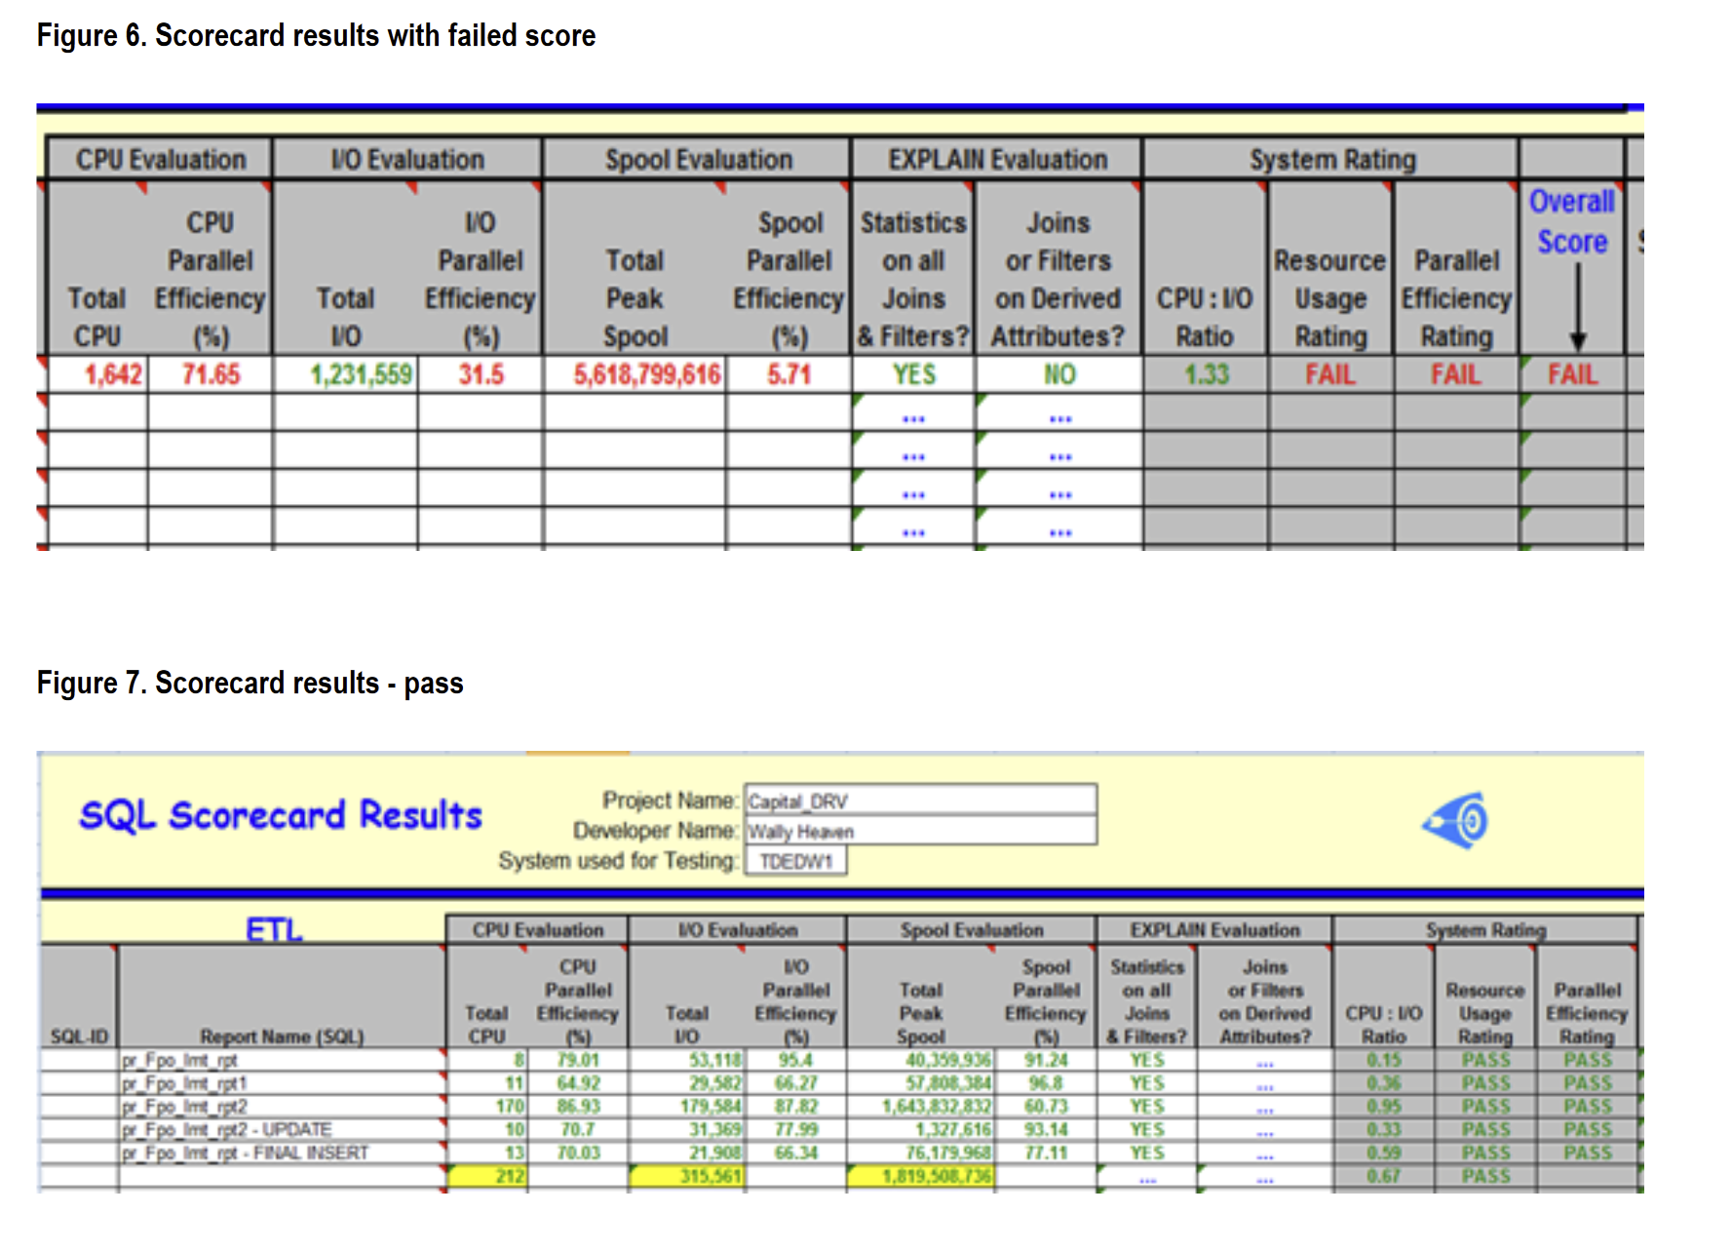
ETL code must go through an ETL Governance Go/No-Go Code Review, and obtain a ‘Go’, prior to the code being migrated to the data warehouse environment. It is important to ensure 100% of the ETL code has passed SQL scorecarding and results are consolidated for review and documentation purposes. ETL code review checklist may be used to help consistency and repeatability, communicate expectations prior to review and improve the efficiency of the scoring and reviewing process.
The review process should utilize an ETL code review check-list. For each object reviewed, the team provides comments on adherence to coding and naming
standards and solicits additional comments from other attendees. As output, the board grants ‘Go’ or ‘No-Go’ based on review of ETL objects and SQL scorecard results with action items documented if additional work is needed.

SQL optimization in parallel processing database system

Database management processing with parallel processing is different from conventional database system. There are two aspects that we need to consider: (1) we need to make sure that database system resources including CPU time and IO utilization are minimal during the load process. This can be done by improving parallel efficiency of SQL. (2) The SQL utilized by analytical tools and ad-hoc queries are parallel efficient.
A parallel processing database system database joins 2 tables (or spool files) at a time and puts the result into a spool file. Then it joins that to another table or spool file, and so on until all the tables are joined. In each of these joins the rows to be joined on each table must reside on the same AMP. If the 2 tables have the same primary index (PI) then all the rows that will join together already reside on the same AMP.
To improve performance two things can be done: narrow down the rows and columns of that small table; if the smaller table contains static data with few records in that case
column values could be placed in memory variables. That way the JOIN with the smaller table could be entirely eliminated.
To avoid data volatility, the data values should not often change for an index column. Any changes to PI values may result in heavy I/O overhead. Join activity against
the PI definition. For large tables, the number of distinct Primary Index values should be much greater than the number of AMPs.
The solution to some of the resource intensive queries includes conversion of a derived table (DT) to a global temporary table (GTT). This is because the GTT can have statistics collected whereas the DT cannot. The GTT approach makes the optimizer plans more aggressive and rely more heavily on collected stats as opposed to sampled statistics.
In one experiment we noticed that the UPDATE operation by joining large source table caused CPU consumption of 1,013 seconds. Using a subset of data from large tables with
global temporary tables will help in computing resource saving. In a simulation we noticed that by using global temporary table for a sub-set of data in source table the
UPDATE operation took only 600 CPU seconds.
It is a good idea to use Partitioned Primary Indexes (PPI) whenever possible. The score-card result shows better performance when rows are retrieved based on PPI defined
on a date column (for instance). Queries which specify a restrictive condition on the partitioning column avoid full table scans as distinct PPI-based column values are stored in
buckets. Larger tables are good candidates for partitioning. The greatest potential gain derived from partitioning a table is the ability to read a small subset of the table instead of the entire table.
A parallel processing DBMS system plays two important roles towards maintaining an efficient data warehouse system. First, it helps running load, reporting, and ad-hoc queries faster than queries of traditional data warehouse system. Data warehouses hold mostly historical data of a business enterprise. Most of the tables in a data warehouse hold a large
volume of data. . On the other hand, if a data warehouse cannot return query results within a reasonable time – (less than five minutes) then reporting capability of business tools is impacted. Slowness of a database system is not acceptable to the analytical community. A parallel
efficient database system allows pulling rows much faster.

